Michael Cu, Ny Tran, Christopher Swayne, Justin Pfau

Project #2 - B

Group #6

Project Report

UML Diagram:

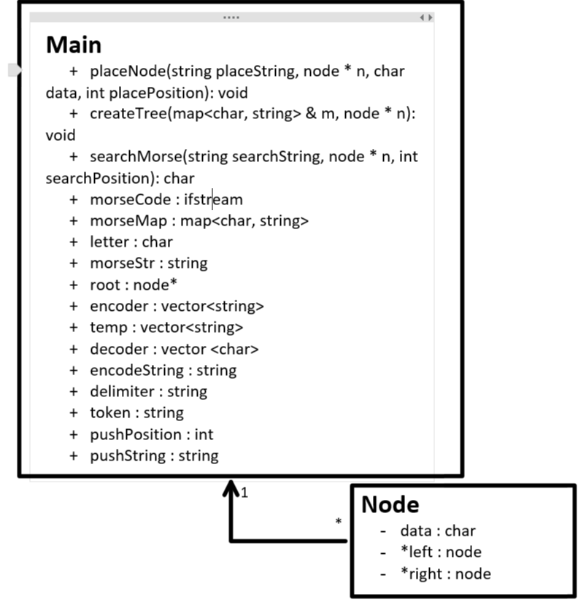

Algorithm Efficiency:

PlaceNode:

Worst Case: O(N)

Best Case: O(N)

Goes to every node and ends on the right most, so goes through N nodes.

SearchMorse:

Worst Case: O(N)

Best Case: O(Log N)

Goes to every node

References:

CodeForGeeks:

<https://www.geeksforgeeks.org/binary-search-tree-set-1-search-and-insertion/>

<https://www.geeksforgeeks.org/linked-complete-binary-tree-its-creation/>

C++ Reference:

<http://www.cplusplus.com/reference/map/map/>

<http://www.cplusplus.com/reference/vector/vector/?kw=vector>